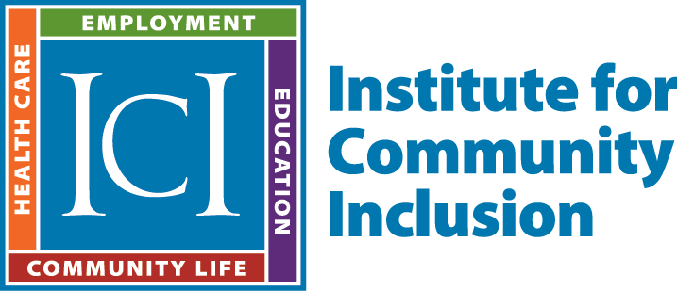
Employment Services Toolkit
Overview and Guidelines

As with any individual, assisting individuals with intellectual and developmental disabilities to become successfully employed requires a thoughtful and deliberate approach regarding identifying employment options, goals, and necessary job supports. The Institute for Community Inclusion has designed a series of tools, based on best practices, to provide a structured approach to the delivery of pre-vocational services, career exploration, job development, and supported employment, and ensure a process that is truly reflective of an individual’s interests and preferences. The tools include the following:
- Prevocational Services: Progress Assessment – A tool for documenting goals and progress in Prevocational Services.
- Career Planning: Checklist - A checklist of items to be addressed as part of Career Planning and initial Job Development.
- Career Planning: Job Exploration Interview/Profile - Tool used to conduct initial collection of information as a starting point in Career Planning and identify areas to be further explored through community-based activities and experiences.
- Career Planning: Discovery Experience Summary – Tool for documentation of exploring employment options and opportunities through experiences in the community.
- Career Planning: Personal Employment Profile - A summary form based on the Job Exploration Interview/Profile, and Discovery Experience Summary, documenting an individual’s preferences, interests, support needs/accommodations and skills.
- Job Development: Action Plan - Action-planning tool to identify job development tasks to be accomplished, due dates for each task, with the names of people who are responsible for completing those tasks.
- Job Development: Business and Job Analysis – For use as part of job development, provides questions and areas of inquiry to guide general information gathering from businesses, and analysis of specific positions for potential employment.
- Job Development: Placement Form - Form to be completed at completion of Job Development when individual becomes employed.
- Supported Employment: Placement Checklist - A checklist of items to be completed, when an individual starts a job and as they begin working.
- Supported Employment: Monthly Retention Plan - Form for documenting progress of individual in their job while receiving supports via Supported Employment services.

Guidelines in the Use of These Tools
- These tools should not be used simply as forms and checklists to be filled out. Their purpose is to provide a structure within which a person-centered, individualized process occurs, that entails creativity, brainstorming, consideration of new and different ideas, and results in employment success.
- Effective use of these tools requires a strong understanding of the values and strategies for successful employment in the community. They should only be used by staff who have been trained on best practices in employment services and support, who understand how to integrate them within the process of effectively assisting an individual with their employment needs.
- Use of these tools is not mandatory nor is it necessary to use every tool for every individual. Consider when use of specific tools makes the most sense in terms of both individuals and situations. For example, for someone with clear job and career goals, the use of these tools may be less intensive, and some tools may not be applicable. However, for someone who has limited work experience and significant support needs, use of all the tools makes sense.
- A core purpose of these tools is to ensure truly “informed choice” characterized by:
- a variety of employment related experiences in fully inclusive settings.
- an opportunity to reflect on those experiences.
Throughout the entire career exploration, job search, and placement process, the individual should be highly active and engaged every step of the way, with their preferences and choices driving the process.
- Use of these tools should align with an Employment First philosophy, in a context that presumes an individual can be successful in employment, and staff are positively encouraging individuals regarding their employment options and dreams. Starting with the presumption of employability, use them to determine what type of job and employment setting an individual can be successful, and what types of assistance and supports are necessary to ensure that success. These tools should not be used to determine whether an individual is “employment ready” or can become successfully employed.

